**Project 1 : House Loan Data**

**Screen Shots**

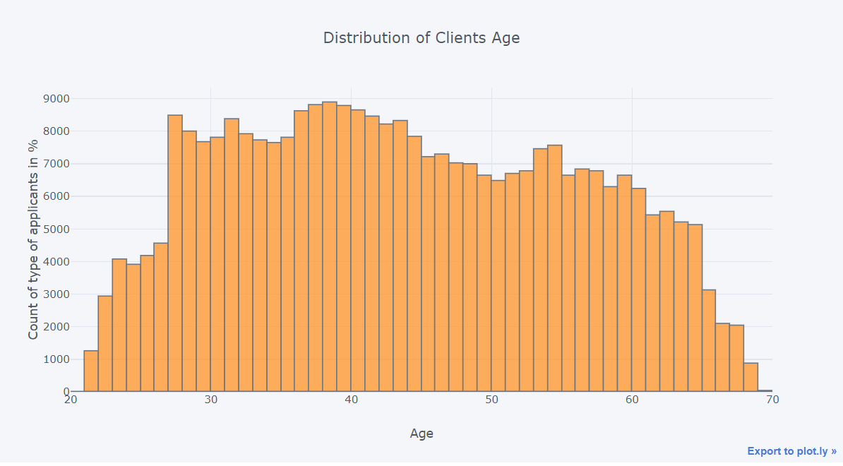

# **Machine Learning Models:**

**Logistic regression with selected features:**

Logistic Regression finds a hyperplane which best seperates the given positive and negative data points.

Cross validation results and plot for Logistic Regression model.

Logistic Regression model results

ROC curve for Logistic Regression model with AUC=0.754

**Random Forest with selected features:**

Cross validation results for Random Forest model.

Random Forest model results.

ROC curve for Random Forest model with AUC=0.75

**LightGBM with selected features:**

LightGBM model Results

**ROC curve for LightGBM model with AUC=0.787**

## Overview of Results:

|  |  |  |  |
| --- | --- | --- | --- |
| **Model** | **Train AUC** | **Validation AUC** | **Test AUC** |
| Logistic Regression with Selected features | 0.756 | 0.747 | 0.753 |
| Random Forest with Selected features | 0.841 | 0.751 | 0.751 |
| **LightGBM with Selected features** | **0.861** | **0.781** | **0.787** |

**LightGBM** gives the best performance and it is also faster to train when compared to Xgboost.